**Question:** You are on the check-out screen of an ecommerce platform. The business rule is that is you are a non-profit organization; you do not have to pay any tax. Introduce the capability of the user to enter the Non-profit organization ID and remove the taxes. Create a use case document containing all the relevant information.

**BUSINESS REQUIREMENT DOCUMENT**

**CURRENT BUSINESS PROBLEM**

At the time of checkout, the cashier does not have the ability to remove/delete the tax for a customer which has a non-profit business account. As a result of this we are losing the business from non-profit business account holders.

**PROPOSED SOLUTION**

The goal of the project is to create an ability for the cashier to enter the tax exempt id of the non-profit business account holders and the system should remove/delete the tax of such customers.

**SYSTEMS IMPACTED**

POS System

**BUSINESS REQUIREMENTS**

1. **Business Requirements**
   1. Ability for the cashier to enter tax exempt id
   2. Ability for the manager to approve/reject the request to tax exempt a purchase

**USE CASE DOCUMENTATION**

**Use Case Name:** Enter tax exempt ID

**Use Case Story**: This case enables the cashier to enter tax exempt id and help non-profit business account holder and remove/delete the tax

**Primary Actor**: Cashier, Manager

**Trigger**: Cashier clicking ‘Enter tax exempt id’ hyperlink

**Post Condition**: System removes the tax from the system

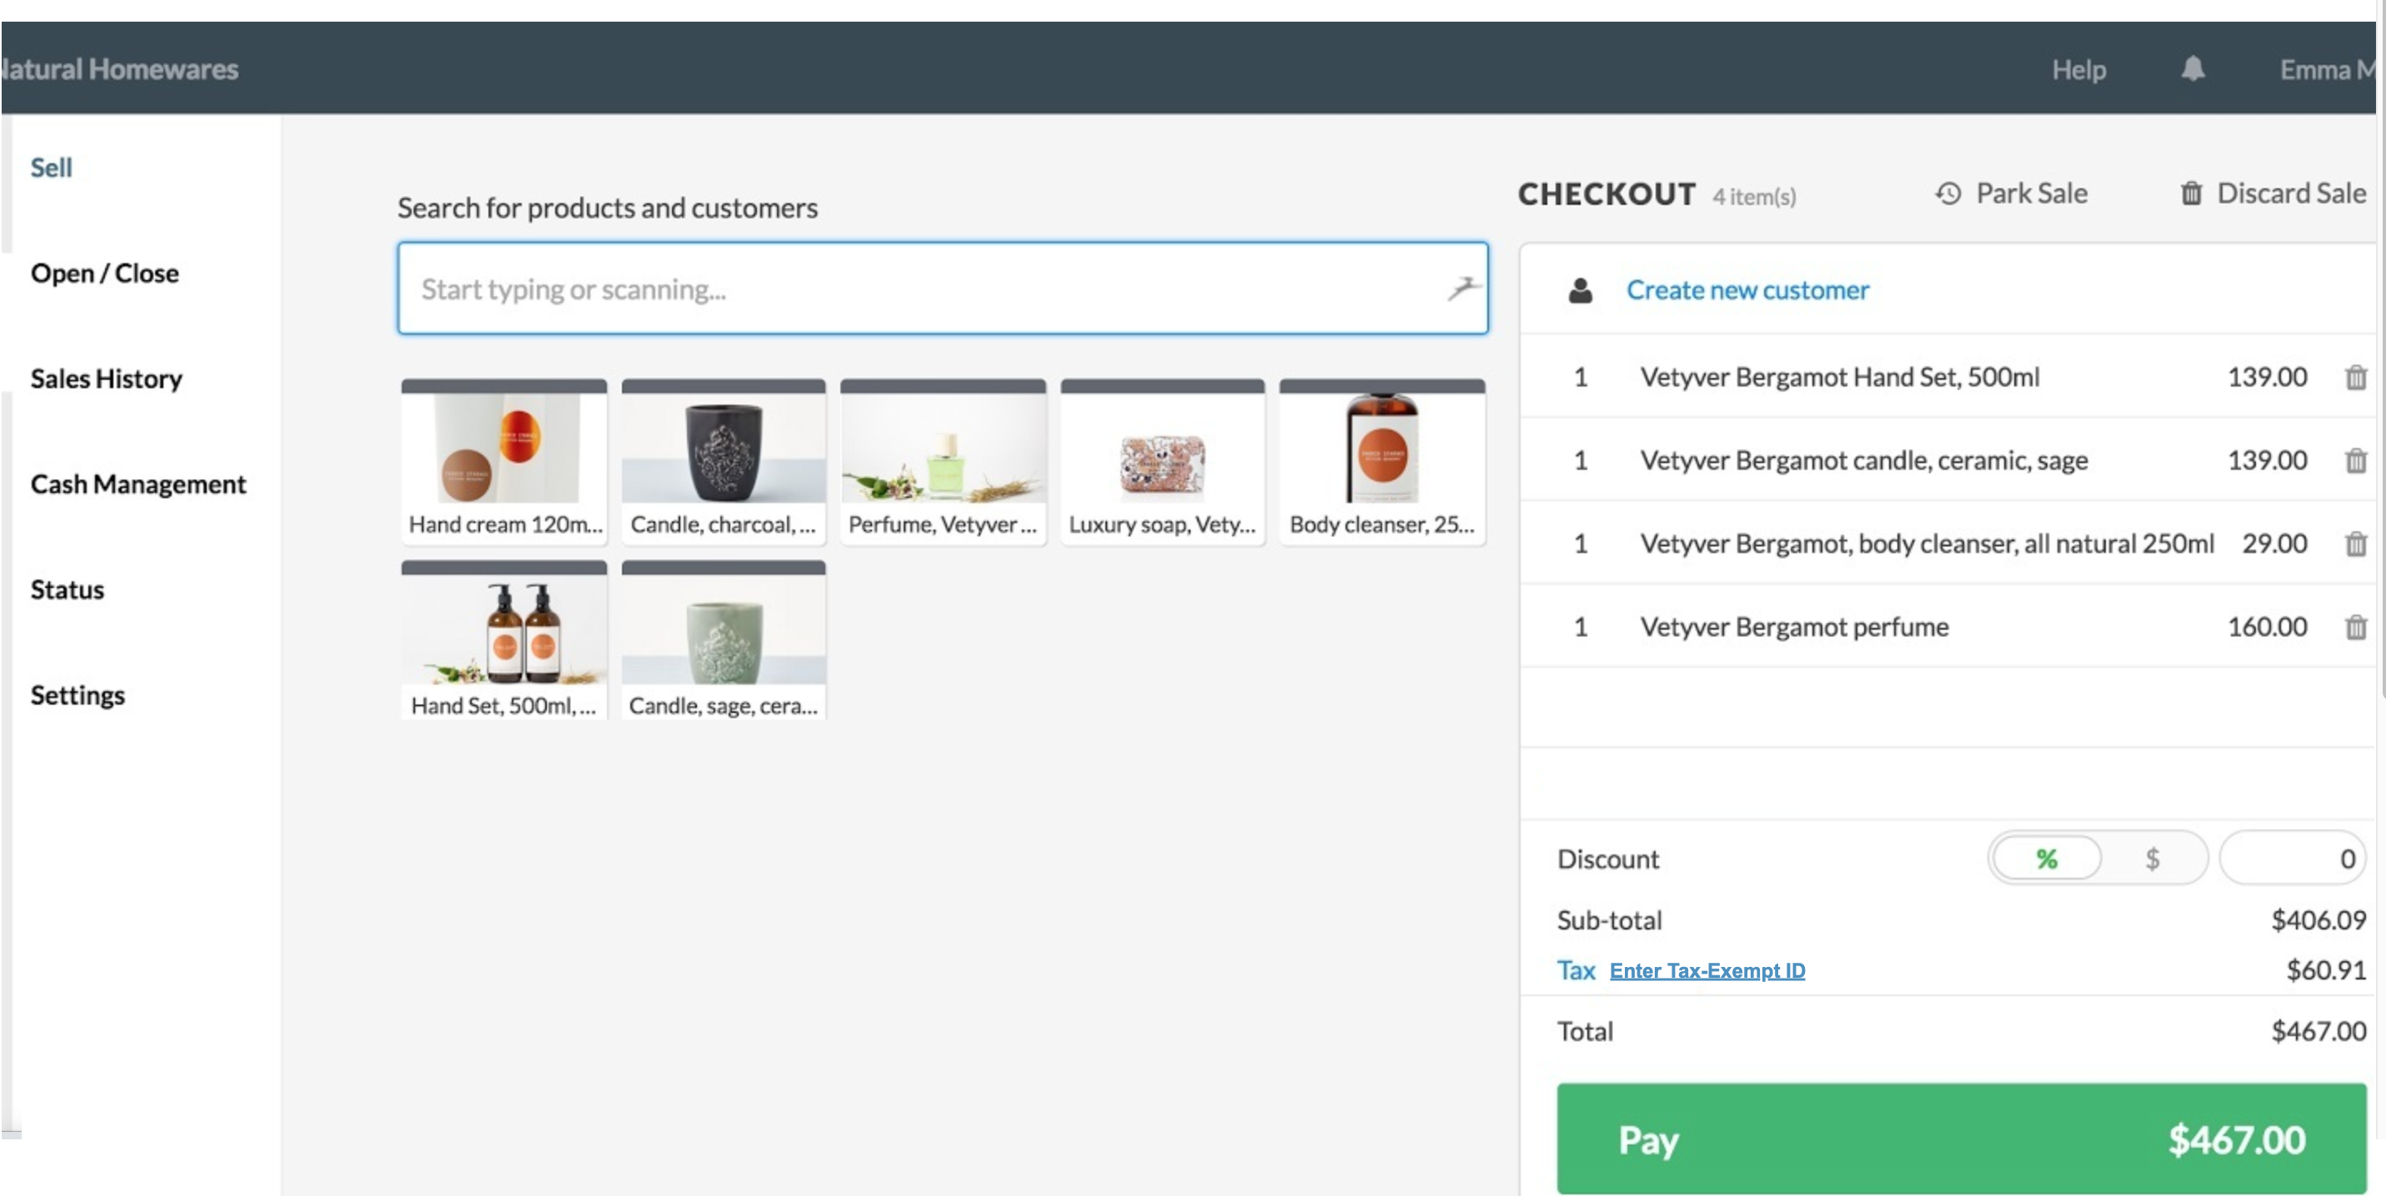

|  |  |  |  |  |  |
| --- | --- | --- | --- | --- | --- |
| **Field Name** | **Field Type** | **Required?** | **Min. Char** | **Max Char** | **Notes** |
| Enter Tax-Exempt ID | Hyperlink | No | N/A | N/A | On click, displays the pop-up for the cashier to enter Tax-Exempt ID |

**Primary Flow**

**Title:** Cashier is able to remove the tax associated with the purchase

|  |  |
| --- | --- |
| **Actor Action** | **System Response** |
| 1. Cashier clicks ‘Enter tax exempt Id’ hyperlink | 1. System displays a pop-up window which allows the cashier to enter the tax-exempt id (Refer Wireframe 2) |
| 1. Cashier enters the tax-exempt id |  |
| 1. If the cashier decides to click ‘Submit’ button go to next step   If the cashier decides to click ‘Cancel’ button go to Exception Flow 1 |  |
| 1. Cashier clicks ‘Submit’ button |  |
|  | 1. System validates tax exempt id format.   If valid go to next step  Else go to Alternate Flow 1. |
|  | 1. System validates tax exempt id.   If valid, go to next step.  Else go to Exception flow 2. |
|  | 1. System checks the tax -exempt amount.   If the tax amount is <= 50, go to next step  Else  If the tax amount is > 50, go to Alternate Flow 2 |
|  | 1. System   closes the pop up  updates the tax amount updates the grand total  removes the hyperlink  (Refer to wireframe 3) |

**Alternate Flow 1**

**Title:** Invalid Tax ID Format

|  |  |
| --- | --- |
| **Actor Action** | **System Response** |
|  | 1. System displays the following error message: ‘Invalid tax ID format. Please re try’. (Refer Wireframe 4) |
| 1. Go to step 3 of Primary flow |  |
|  |  |

**Alternate Flow 2**

**Title:** Tax amount > 50

|  |  |
| --- | --- |
| **Actor Action** | **System Response** |
|  | 1. System displays manager approval pop up (Refer Wireframe 5) |
| 1. Manager enters user id and pin |  |
| 1. If the manager decides to click the ‘Submit’ button, go to next step   Else  If the manager decides to click ‘Cancel’ button go to exception flow 1. |  |
| 1. Manager clicks ‘Submit’ button |  |
|  | 1. System validates manager user id and pin   If valid, go to the next step  Else  If invalid, go to Alternate Flow 3 |
|  | 1. Go to step 9 of Primary Flow |

**Alternate Flow 3**

**Title:** Invalid manager user id/pin

|  |  |
| --- | --- |
| **Actor Action** | **System Response** |
|  | 1. System displays the following error message: ‘Invalid User ID/Pin. Please enter a valid User ID/Pin’.(Refer Wireframe 6) |
| 1. Go to step 2 of Alternate Flow 2 |  |

**Exception Flow 1 (EF1):**

**Title:** Invalid Manager User ID/Pin

|  |  |
| --- | --- |
| **Actor Action** | **System Response** |
| 1. Cashier/Manager clicks ‘Cancel’ button | 1. System closes the pop-up and the tax value remains the same. |

**Exception Flow 2 (EF2):**

**Title:** Tax ID Entered is Not Tax Exempt

|  |  |
| --- | --- |
| **Actor Action** | **System Response** |
|  | 1. System does the following:  * Displays the following error message: Entered Tax ID is NOT tax-Exempt * Hides ‘Submit’ button   (Refer Wireframe 7) |
| 2. Cashier clicks ‘Cancel’ button | 3. System closes the pop-up and the tax value remains the same. |

**Wireframe 2**

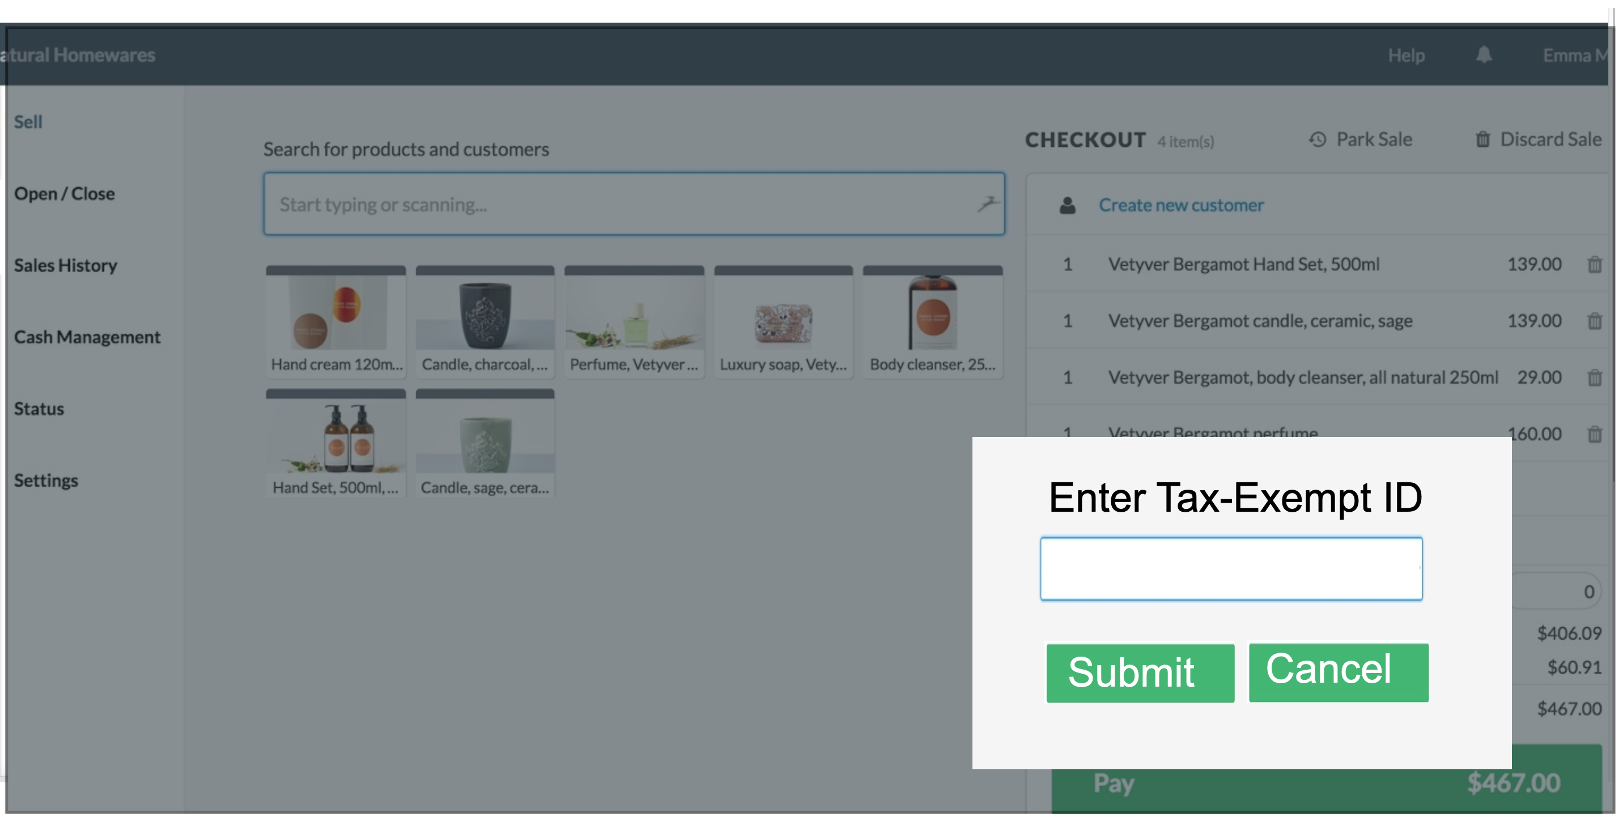

|  |  |  |  |  |  |  |
| --- | --- | --- | --- | --- | --- | --- |
| **Field Name** | **Field Type** | **Data Type** | **Required?** | **Min. Char** | **Max Char** | **Notes** |
| Enter Tax-Exempt ID | Text Box | Numeric | Yes | 9 | 9 |  |
| Submit | Button | N/A | N/A | N/A | N/A | On click, if validations pass:   * Displays manager approval pop up if Tax amount >50, closes the pop-up |
| Cancel | Button | N/A | N/A | N/A | N/A | Closes the pop-up |

**Wireframe 3**

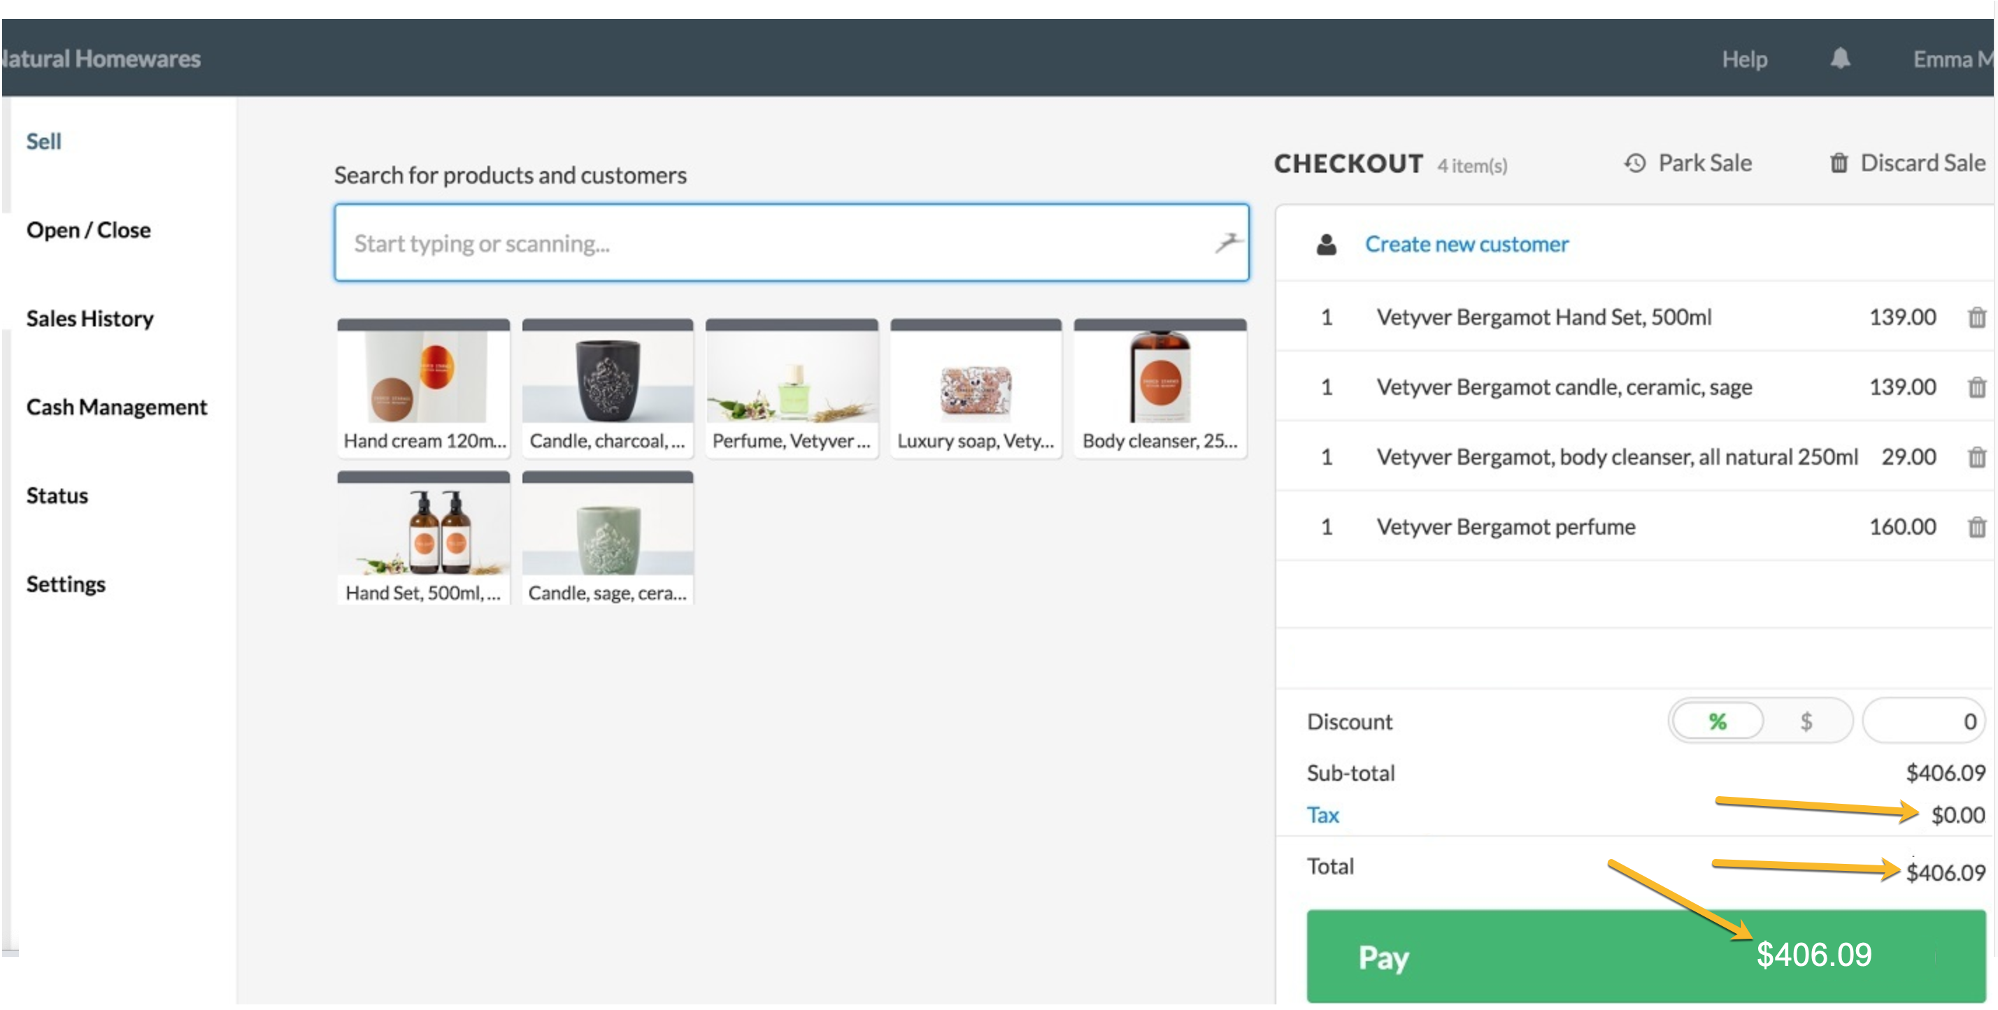

**Wireframe 4**

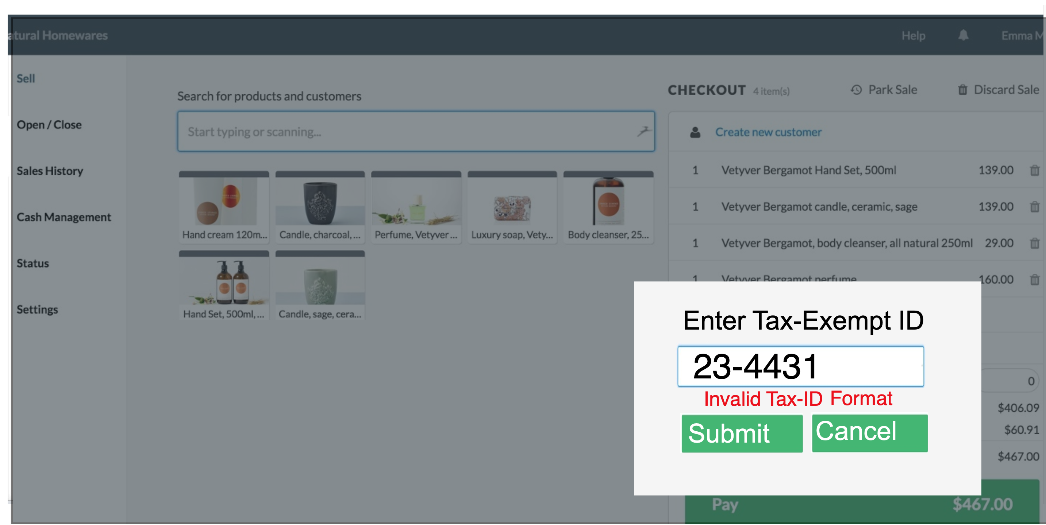

**Wireframe 5**

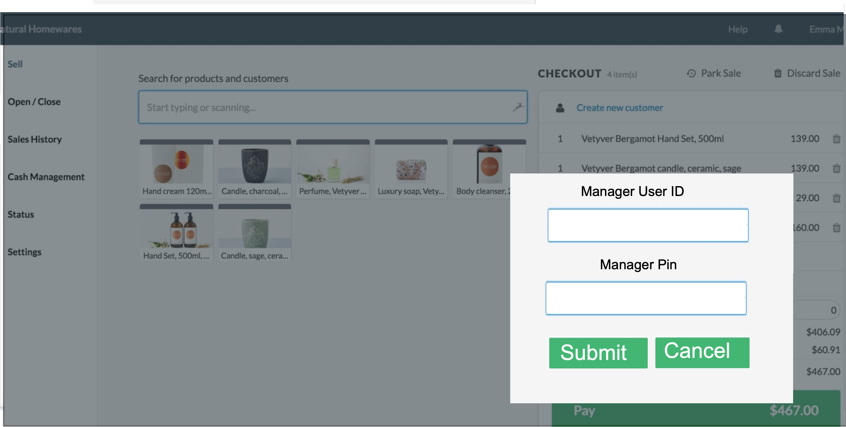

|  |  |  |  |  |  |  |
| --- | --- | --- | --- | --- | --- | --- |
| **Field Name** | **Field Type** | **Data Type** | **Required?** | **Min. Char** | **Max Char** | **Notes** |
| Manager User ID | Text Box | Alphanumeric | Yes | 5 | 5 |  |
| Manager Pin | Text Box | Numeric | Yes | 4 | 4 | Encrypt the entered data |
| Submit | Button | N/A | N/A | N/A | N/A | On click, if validations pass, close the pop else display error message |
| Cancel | Button | N/A | N/A | N/A | N/A | Closes the pop-up |

**Wireframe 6**

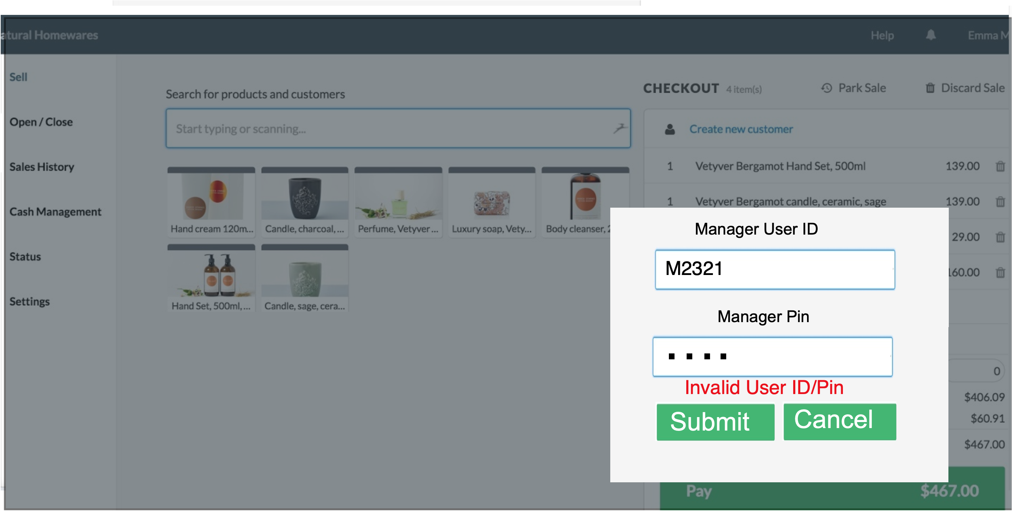

**Wireframe 7**

